Your EDEXCEL GCSE Speaking Exam in Gujarati:

How to prepare and get the best grade

*References in this document have been made to materials available on the Edexcel webpages for GCSE Gujarati:* [*https://qualifications.pearson.com/en/qualifications/edexcel-gcses/gujarati-2018.html*](https://qualifications.pearson.com/en/qualifications/edexcel-gcses/gujarati-2018.html)

You will have been entered for either the **Foundation** or **Higher** Tier for your speaking exam.

For the Foundation Tier the speaking exam lasts for **7-9 minutes** and for the Higher Tier it will last for **10-12 minutes**.

The examination for both Foundation and Higher tiers has three parts:

1. **A role play** – for Foundation Tier this will last for up to 1.5 minutes and for Higher Tier up to 2.5 minutes
2. **A Picture based discussion** – for Foundation Tier this will last for up to 2.5-3 minutes and for Higher Tier up to 3.5-4 minutes
3. **A General Conversation** between you and the examiner with questions related to the **themes** on page 2 of this document. The Conversation must cover **two different themes**. You choose the first theme that is discussed. Whichever theme you choose for the General Conversation, this will not be the theme of your Picture based discussion. This part of the exam will last for 3.5 to 4 minutes for Foundation Tier and for 5 to 6 minutes for the Higher Tier.

Before your speaking exam you will be given 12 minutes of **preparation time**. At the beginning of this preparation time you will be given a role play (part 1 of the exam) and a picture based discussion (part 2 of the exam) to prepare. You must not write on the materials you are given, but you can make up to one side of A4 of notes to help you with parts 1 and 2 of the exam. You cannot make any notes to help you with the General Conversation (part 3).

**You must choose from either Theme 1, 2, 3, 4 or 5 for the General Conversation in advance of the speaking examination, as this will determine which role play card and picture based discussion you are given to prepare.**

There is no break between the three parts of the exam. It is recorded continuously. The person conducting the exam does not mark it – it will be sent directly to the examination board.

**Themes**

For the general conversation, you must choose a Theme (either 1, 2, 3, 4 or 5) from the list below. This will be the first theme that is discussed **and you will have up to one minute to introduce the subtopic from your chosen theme** before the examiner asks you any questions. Whichever theme you choose, will not be the theme for your Picture based discussion.

**Theme 1 – Identity and Culture**

**Topic 1 – Who am I?** – relationships friends and families, socialising with friends and family

**Topic 2 - Daily Life** - customs and everyday life, food and drink, social media and technology (advantages and disadvantages)

**Topic 3 – Cultural Life** – celebrations and festivals, reading, music, sport, film and television

**Theme 2 – Local Area, Travel and Holiday**

**Topic 1 – Holidays** – Preferences, experiences and destinations

**Topic 2 – Travel and Tourist Destinations** – Travel and accommodation, asking for help and dealing with problems, directions, eating out, shopping

**Topic 3 – Town, Region and Country**– Weather, places to see, things to do

**Theme 3 – School**

**Topic 1 – What School is like** – school types, school day, subjects, rules and pressures, celebration success

**Topic 2** **– School Activities** – School trips, events and exchanges

**Theme 4 – Future Aspirations, Study and Work**

**Topic 1 – Using languages beyond the classroom** – forming relationships, travel and employment

**Topic 2** **– Ambitions** – Further study, volunteering and training

**Topic 3 – Work** – Jobs, careers and professions

**Theme 5 – International and Global Dimension**

**Topic 1 – Bringing the world together** – Sports events, music events, campaigns and good causes

**Topic 2 – Environmental Issues** – “being green”, access to natural resources

**What the examiner is looking for**

It is important that you know how to prepare the role play and the picture card in advance of examination day. Go to the Edexcel webpage for your language and find the speaking exam materials which will have lots of examples of role play and picture based discussion cards. Pick a role play card and a picture based discussion card and try to prepare the role play and the picture based discussion card within 12 minutes, as if you were doing the real preparation time, before the real exam. Read the next section before you prepare the role play card and picture based discussion card for some hints and tips for how to be successful.

**How to prepare and practise**

**Part 1 - Role Play (see Appendix 1 for Foundation and see Appendix 3 for Higher)**

For this part of the examination you need to show that you can communication a message or idea. Your language doesn’t have to be perfect, but it is important that the message or idea is understood. For the role play you will play one part, and the examiner will have a script with the other part of the conversation written on it.

At the top of the role play card it will say whether you have to speak to the other person (the examiner) formally or informally. If for example you are asked to have a conversation with a friend, then you would use the informal form. However sometimes you will need to have a more formal conversation and you would then use the formal form. Look at the top of the role play card for your language and work out if you should use the formal or informal form.

When you see a **?** on the role play card this means that you need to ask a question using the words on the card.

When you see a **!** on the role play card this means that you the examiner will say something from their script which you were not able to prepare in advance. This will be an “unknown” question that will form part of the conversation.

There will always be 5 bullet points that need to be covered for this part of the examination.

**Part 2 – Picture based discussion (see Appendix 2 for Foundation and see Appendix 4 for Higher)**

For this part of the examination you will be asked questions about a photo that you have been given printed on a card at the beginning of your preparation time. The photo will always be in colour.

There will be 4 questions printed on the card. The first question will always be:

“What is in the photo?”

Therefore, you can practise describing photos to prepare for this part of the examination. You can use phrases in your language such as “I can see _____ in the photo” or “In the photo there is ____” to start your description.

You can also use phrases in your language to describe where things or people are placed in the picture such as:

Next to, behind, in front of, in the foreground, in the background, to the left of, to the right of…

You can also describe what people are doing in the photo, so you will need to know the present tense to say for example “the person is recycling”

The next two questions will be about your opinions to do with the photo card. Don’t forget to get the highest marks you should justify your opinions i.e. say why you have the opinion you have.

There are 5 questions for this part of the exam in total. For Foundation all the questions are printed on the picture based discussion card. For Higher you have 4 questions printed on your version of the picture based discussion card. Therefore the examiner has **1 more question** that you will not see in the preparation time. They will be on the same topic, so if you have time during the 12 minute preparation time, try to write down some of your opinions about the topic in general.

**Part 3 – General Conversation**

It is important that you choose a theme that you can talk about fluently and be prepared to discuss further. **You will have up to one minute to present** your chosen subtopic from your chosen theme before the examiner asks you any questions. You will be asked questions about your chosen theme and the examiner is looking for **ability to express opinions, present information, deal with unexpected elements and use a variety of structures.**

It is important that you can use **different tenses** including present, past and future. The person conducting the exam will ask questions to encourage you to use these tenses.

To gain a good grade you must **give opinions and explain them**. You must also **express feelings**. If you say you liked your holiday then you must say **why** you liked it, if other people liked it or not, and how it made you feel. Using words such as ‘**because’** and’ **however**’ will help you to use longer, extended sentences that will also get you extra marks.

For the general conversation you must be prepared to discuss and answer questions relating to your own experience, and the experience of other people, including in countries/communities where the language is spoken.

**Overall for the Speaking Exam**

Look at the themes and subtopics and try to write down some of the vocabulary that is linked to that subtheme. For example, for the subtheme of Environmental Issues, you need to think about words linked to this topic such as recycling, global warming, pollution, solar energy etc. You can find a full list of vocabulary at the end of the specification for your language – the specification is available from the Edexcel webpage for your language.

Once you have chosen your theme prepare your introduction. You will have one minute to introduce your theme. When practising you could write out your introduction in full. You could then go through it and look for different tenses, and check for longer sentences, connecting words and opinions. Once you have improved it make a bulleted note for each point to help you practise but remember you cannot take any notes in the exam for the general conversation.

Now try it out with your friends or family, using just the notes if possible. Ask them to ask you questions about it and explain to them that you have to use different tenses and give opinions. Ask them if they can suggest any better words or phrases than the ones you have used. Try to do it without reading from the written version – you won’t be able to do that in the exam. Working with a friend can motivate you both.

Don’t forget your friends or family can also help you to prepare for the parts 1 (the role play) and 2 (the photo card) of the exam. Perhaps they can look at the role play and photo card (the teacher version) and ask you the questions, after you have completed your practice preparation time. They could also ask you questions to practise for the general conversation based on the subthemes.

* Try to sound natural particularly during part 1 the role play card and part 2 the photo card, avoid reading out your notes directly from the page that you have written during the preparation time
* Avoid using slang or very informal language. The standard form of the language should be used as much as possible – this may not be quite the same as the form of the language you use at home with family and friends!
* It is important to avoid giving one or two word answers. It is meant to be a natural conversation or discussion and must not sound rehearsed or like an interview. Give extended answers, your opinions and the opinions of others, and detailed descriptions when you can.

**Remember: preparation is the key to success. Spend some time preparing and practising the role play cards and photo cards in advance. Choose the best theme for you for the general conversation and become confident in introducing and discussing this theme.**

*All the example materials used in the following appendices can be found on the following site* [*https://qualifications.pearson.com/en/qualifications/edexcel-gcses/gujarati-2018.html*](https://qualifications.pearson.com/en/qualifications/edexcel-gcses/gujarati-2018.html)

**Appendix 1 – Foundation Role Play Card**

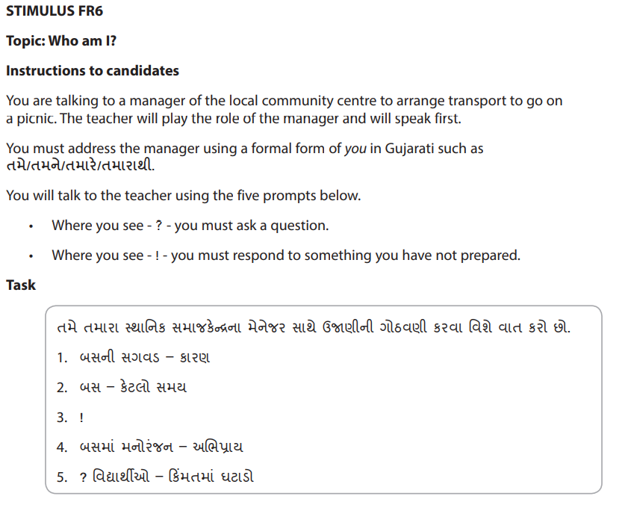

**Appendix 2 – Foundation Picture Based Discussion**

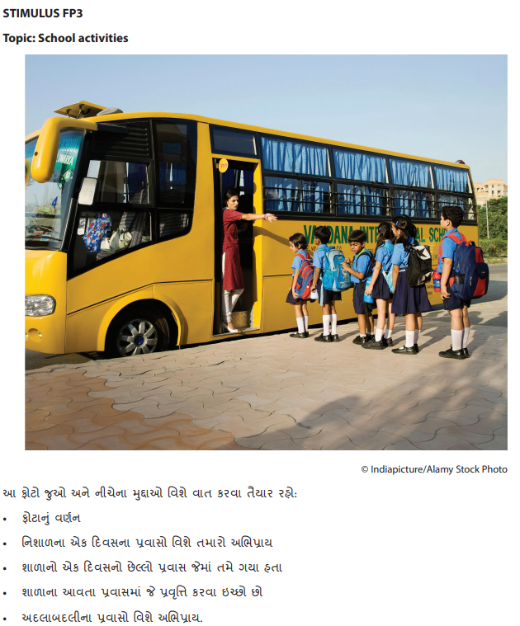

**Appendix 3 – Higher Role Play Card**

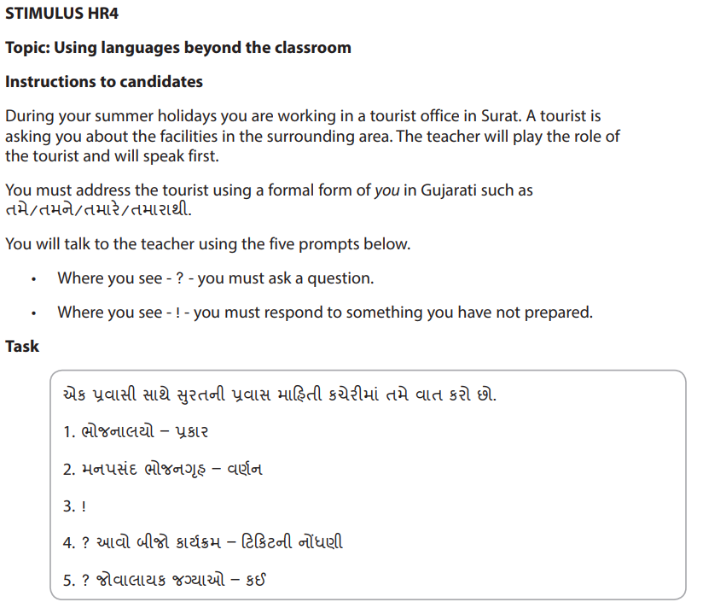

**Appendix 4 – Higher Picture Based Discussion**

