Your AQA GCSE Speaking Exam in French:

How to prepare and get the best grade

*References in this document have been made to materials available on the AQA webpages for GCSE French:*

<https://www.aqa.org.uk/subjects/languages/gcse/french-8658>

You will have been entered for either **Foundation** or **Higher** Tier for your speaking exam.

For the Foundation Tier the speaking exam lasts for **7-9 minutes** and for the Higher Tier it will last for **10-12 minutes**.

The examination for both Foundation and Higher tiers has three parts:

1. **A role play** – for Foundation Tier this will last for up to 1 minute and for Higher Tier up to 2 minutes
2. **A Photo Card** – for Foundation Tier this will last for up to 2 minutes and for Higher Tier up to 3 minutes
3. **A General Conversation** between you and the examiner with questions related to the theme on page 2 of this document. The Conversation must cover **two different themes**. You can choose the first theme that is discussed. Whichever theme you choose for the General Conversation will not be the theme of your Photo Card. This part of the exam will last for 3 to 5 minutes for Foundation Tier and for 5 to 7 minutes for the Higher Tier.

Before your speaking exam you will be given 12 minutes of **preparation time**. At the beginning of this preparation time you will be given a role play (part 1 of the exam) and a photo card (part 2 of the exam) to prepare. You must not write on the materials you are given, but you can make notes to help you with parts 1 and 2 of the exam. You cannot make any notes to help you with the General Conversation (part 3).

**You must choose from either Theme 1, 2 or 3 for the first part of the General Conversation in advance of the speaking examination as this will determine which role play card and photo card you are given to prepare.**

There is no break between the three parts of the exam. It is recorded continuously. The person conducting the exam does not mark it – it will be sent directly to the examination board.

**Themes**

For the general conversation, you must choose a Theme (either 1, 2 or 3) from the list below. This will be the first theme that is discussed. Whichever theme you choose, will not be the theme for your Photo card.

**Theme 1 – Identity and Culture**

**Topic 1 - Me, my family and friends** – relationship with family and friends, marriage/partnerships

**Topic 2 - Technology in Everyday Life** - social media, mobile technology

**Topic 3 - Free time activities –** Music, Cinema and TV, Food and eating out, Sport

**Topic 4 - Customs and Festivals** – relating to the country where the language is spoken

**Theme 2 – Local, national, international and global areas of interest**

**Topic 1 – Home, town neighbourhood and region**

**Topic 2 – Social Issues** – Charity/voluntary work, healthy and unhealthy living

**Topic 3 – Global Issues** – The environment, poverty/homelessness

**Topic 4 – Travel and tourism**

**Theme 3 – Current and Future Study and Employment**

**Topic 1 – My studies**

**Topic 2** **– Life at School/College**

**Topic 3** – **Education Post-16**

**Topic 4** – **Jobs, career choices and ambitions**

**What the examiner is looking for**

It is important that you know how to prepare the role play and the photo card in advance of examination day. Go to the AQA webpage for your language and find the speaking exam materials which will have lots of examples of role play and photo cards. Pick a role play card and a photo card and try to prepare the role play and the photo card within 12 minutes, as if you were doing the real preparation time, before the real exam. Read the next section before you prepare the role play card and photo card for some hints and tips for how to be successful.

**How to prepare and practise**

**Part 1 - Role Play (See Appendix 1 Foundation or Appendix 3 Higher)**

For this part of the examination you need to show that you can communication a message or idea. Your language doesn’t have to be perfect, but it is important that the message or idea is understood. For the role play you will play one part, and the examiner will have a script with the other part of the conversation written on it.

At the top of the role play card it will say whether you have to speak to the other person (the examiner) formally or informally. If for example you are asked to have a conversation with a friend, then you would use the informal form. However sometimes you will need to have a more formal conversation and you would then use the formal form. Look at the top of the role play card for your language and work out if you should use the formal or informal form.

When you see a **?** on the role play card this means that you need to ask a question.

When you see a **!** on the role play card this means that you the examiner will say something from their script which you were not able to prepare in advance. This will be an “unknown” question that will form part of the conversation.

There will always be 5 bullet points that need to be covered for this part of the examination.

**Part 2 – Photo Card (See Appendix 2 Foundation or Appendix 4 Higher)**

For this part of the examination you will be asked questions about a photo that you have been given printed on a card at the beginning of your preparation time. The photo will always be in black and white.

There will be 3 questions printed on the card. The first question will always be:

“What is in the photo?”

Therefore you can practise describing photos to prepare for this part of the examination. You can use phrases in your language such as “I can see _____ in the photo” or “In the photo there is ____” to start your description.

You can also use phrases in your language to describe where things or people are placed in the picture such as:

Next to, behind, in front of, in the foreground, in the background, to the left of, to the right of…

You can also describe what people are doing in the photo, so you will need to know the present tense to say for example “the person is recycling”

The next two questions will be about your opinions to do with the photo card. Don’t forget to get the highest marks you should justify your opinions i.e. say why you have the opinion you have.

There are 5 questions for this part of the exam in total. You have 3 questions printed on your version of the photo card. Therefore the examiner has **2 more questions** that you will not see in the preparation time. They will be on the same topic, so if you have time during the 12 minute preparation time, try to write down some of your opinions about the topic in general.

**Part 3 – General Conversation**

It is important that you choose a topic that you can talk about fluently and be prepared to discuss further. You will be asked questions about your chosen theme and the examiner is looking for **ability to express opinions, present information, deal with unexpected elements and use of a variety of structures.**

It is important that you can use **different tenses** including present, past and future. The person conducting the exam will ask questions to encourage you to use these tenses.

To gain a good grade you must **give opinions and explain them**. You must also **express feelings**. If you say you liked your holiday then you must say **why** you liked it, if other people liked it or not, and how it made you feel. Using words such as ‘**because’** and’ **however**’ will help you to use longer, extended sentences that will also get you extra marks.

For the general conversation you must be prepared to discuss and answer questions relating to your own experience, and the experience of other people, including in countries/communities where the language is spoken.

As part of the general conversation **you must ask the examiner a question**.

**Overall for the Speaking Exam**

Look at the themes and subtopics and try to write down some of the vocabulary that is linked to that subtheme. For example, the subtheme of Global Issues includes the topic environment, you need to think about words linked to this topic such as recycling, global warming, pollution, solar energy etc. You can find a full list of vocabulary at the end of the specification for your language. The specification is available from the AQA webpage for your language.

Don’t forget to as your friends or family to help you to prepare. Perhaps they can look at the role play and photo card and ask you the questions after you have completed your practice preparation time. They could then ask you questions to practise for the general conversation based on the subthemes. Ask them if they can suggest any better words or phrases than the ones you have used.

* Try to sound natural particularly during part 1 the role play card and part 2 the photo card, avoid reading out your notes directly from the page
* Avoid using slang or very informal language. The standard form of the language should be used as much as possible – this may not be quite the same as the form of the language you use at home with family and friends!
* It is important to avoid giving one or two word answers. It is meant to be a natural conversation or discussion and must not sound rehearsed or like an interview. Give extended answers, your opinions and the opinions of others, and detailed descriptions.

**Remember: preparation is the key to success. Spend some time preparing and practising the role play cards and photo cards in advance. Choose the best theme for you for the general conversation and become confident in discussing this theme. Don’t forget you have to ask the examiner a question during the general conversation.**

*All the example materials used in the following appendices can be found on the following site:* [*https://www.aqa.org.uk/subjects/languages/gcse/french-8658*](https://www.aqa.org.uk/subjects/languages/gcse/french-8658)

**Appendix 1 – Foundation Role Play Card**

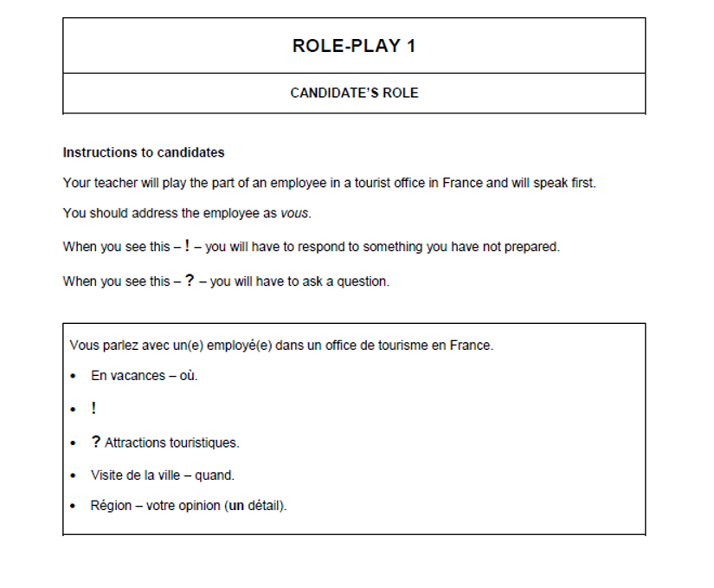

**Appendix 2 – Higher Role Play Card**

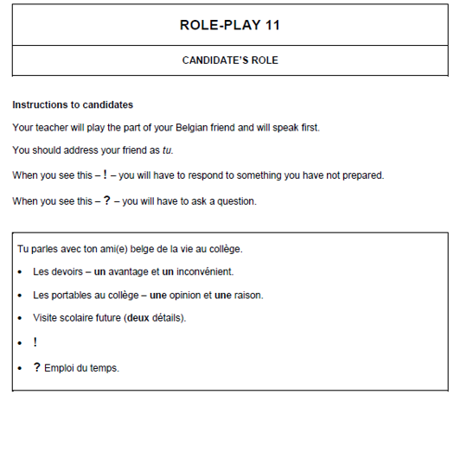

**Appendix 3 – Foundation Photo Card**

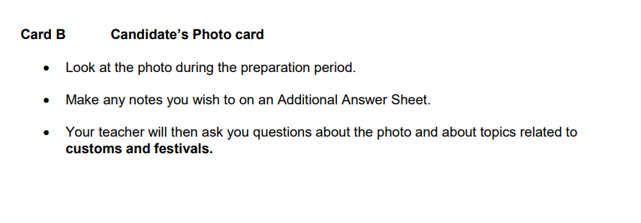



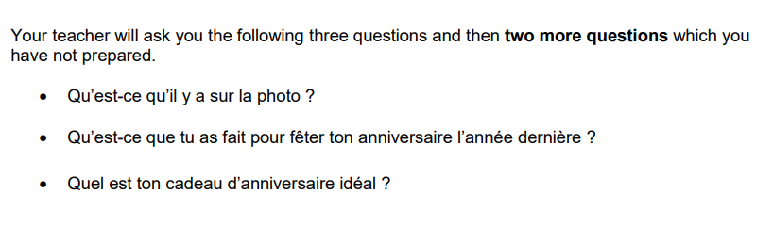

**Appendix 4 – Higher Photo Card**

